**Name: Mohammad Awais**

**Class: BSCS-8-A**

**CMS: 242554**

Compiler Construction Lab 5

# **Task 1**

### Code:

%%

(("if"|("then")|("begin")|("end")|("procedure")|("function"))) {printf("A keyword: "); ECHO; printf("\n");}

([+-/*]) {printf("An Operator: "); ECHO; printf("\n");}

([\n\t" "]) {}

(([0-9]+)(.[0-9]+)) {printf("A float: "); ECHO; printf("\n");}

(([0-9]+)) {printf("A integer: "); ECHO; printf("\n");}

([a-z]+[0-9a-zA-Z]*) {printf("An id: "); ECHO; printf("\n");}

. {printf("Unrecognized character: "); ECHO; printf("\n");}

%%

int main(int argc, char **argv)

{

FILE *file = fopen("testcode","r");

if(!file){

printf("[-] Can't open the file!\n");

return -1;

}

yyin=file;

while(yylex());

fclose(file);

printf("\n");

}

### Output:

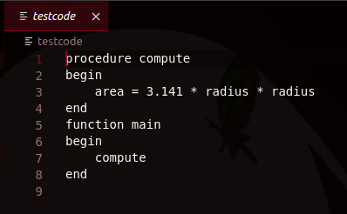**Input Code File**

**Terminal Output**

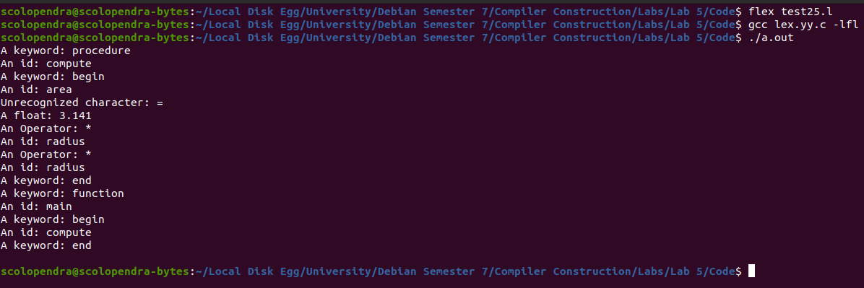

# Task 2

### Code:

%{

int result;

int MAXSIZE = 4;

int stack[4];

void push(int data){

for (int i = MAXSIZE-1; i>0;i--){

stack[i]=stack[i-1];

}

stack[0] = data;

}

int pop(){

int data = stack[0];

for (int i = 0; i<MAXSIZE;i++){

stack[i]=stack[i+1];

}

return data;

}

%}

%%

([+-/*]) {

int b = pop();

int a = pop();

int result=0;

switch(yytext[0]){

case '+':{

result = a+b;

break;

}

case '-':{

result = a-b;

break;

}

case '*':{

result = a*b;

break;

}

case '/':{

result = a/b;

break;

}

}

push(result);

printf("\n%d %d %d %d\n", stack[0], stack[1], stack[2], stack[3]);

}

([\n\t" "]) {}

(([0-9]+)) {

push(atoi(yytext));

printf("\n%d %d %d %d\n", stack[0], stack[1], stack[2], stack[3]);}

. {printf("Unrecognized character: "); ECHO; printf("\n");}

%%

int main(int argc, char **argv)

{

FILE *file = fopen("testcode2","r");

if(!file){

printf("[-] Can't open the file!\n");

return -1;

}

yyin=file;

while(yylex());

fclose(file);

printf("\n[+] Result = %d\n\n",stack[0]);

}

### Output:

**Input File**

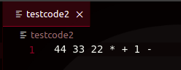

**Terminal Output**

